# Sensor name:

# Proximity sensor

**proximity sensorSensor use:**

Is a [sensor](https://en.wikipedia.org/wiki/Sensor) able to detect the presence of nearby objects without any physical contact

Uses with smartphones and tablet computers

**Digram:**

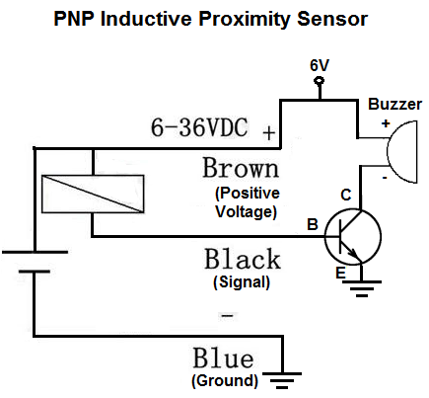

**Sensor From:**

Future electronics

[https://store.fut-electronics.com](https://store.fut-electronics.com/)

**sensor code:**

//collects data from an analog sensor

int sensorpin = 0; // analog pin used to connect the sharp sensor

int val = 0; // variable to store the values from sensor(initially zero)

void setup()

{

Serial.begin(9600); // starts the serial monitor

}

void loop()

{

val = analogRead(sensorpin); // reads the value of the sharp sensor

Serial.println(val); // prints the value of the sensor to the serial monitor

delay(400); // wait for this much time before printing next value

}